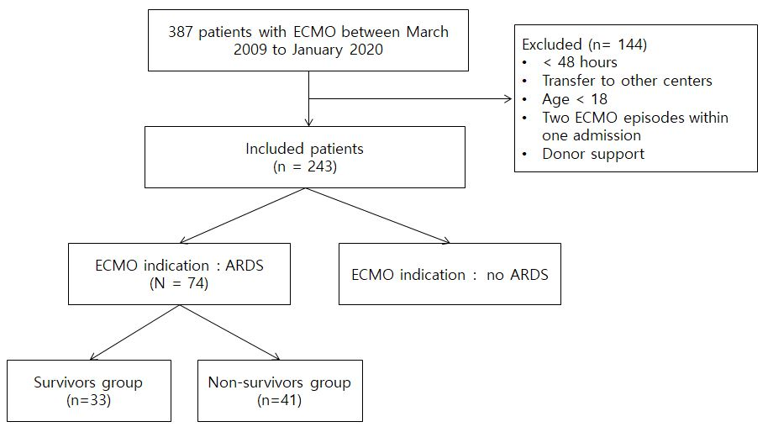
Fig. 1 Flowchart of participant enrollment.
ECMO : extracorporeal membrane oxygenation, ARDS : acute respiratory distress syndrome
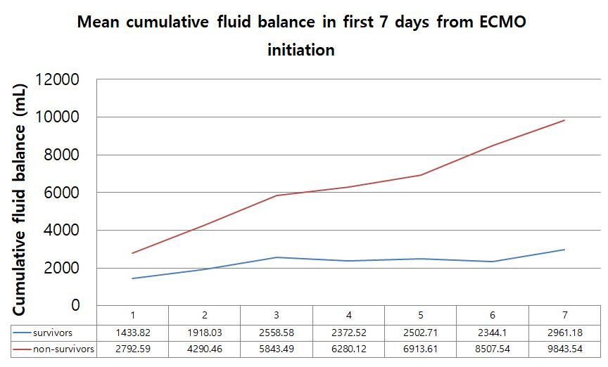
Fig. 2 Mean cumulative fluid balance in first 7 days from ECMO initiation in survivors and non-survivors.
Survival was based on 28-day mortality. Non-survivors are marked red and survivors are marked blue. The cumulative fluid balance is on the Y-axis and duration from ECMO initiation is on X-axis.
ECMO : extracorporeal membrane oxygenation

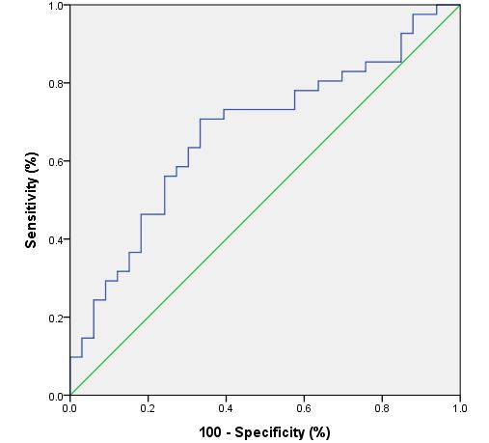

Fig. 3. Receiver operating characteristics curve of cumulative fluid balance on day 3 and 28-day mortality.

An optimal cut-off value was 2632 mL, which showed a sensitivity and specificity of 70.7 % and 66.7%, respectively
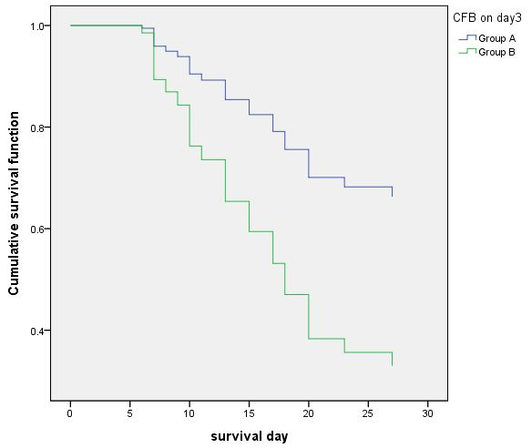
Fig. 4 Cumulative survival curves of Group A and B estimated using Cox regression analysis.
Group A :CFB on day 3 < cut-off value (2632 mL), n= 35
Group B :CFB on day 3 > cut-off value (2632 mL ), n=39
28-day mortality rate is % 37 % in group A, and 72% in group B ( p = 0.002)
CFB : Cumulative fluid balance

Table 1. Patient characteristics by 28-day survival status
 | Survivors (n=33) | Non-survivors (n=41) | P-value
Age (years) | 53.24 ± 2.633 | 59.32 ± 2.490 | 0.100
Sex (male, %) | 16 (48.5 %) | 17 (41.5 %) | 0.546
BMI | 25.3 ± 0.645 | 24.44 ± 0.654 | 0.356
Comorbidity
HTN | 14 (42.4%) | 20 (48.8%) | 0.585
DM | 6 (18.2%) | 9 (22.0%) | 0.688
CKD | 3 (9.1%) | 4 (9.80%) | 1.000
Malignancy | 5 (15.2%) | 10 (24.4%) | 0.326
Immune suppression | 8 (24.2%) | 13 (31.7%) | 0.479
ICU score
APACHE II | 13.27 ± 5.642 | 14.83 ± 5.603 | 0.240
SOFA | 6.48 ± 3.938 | 6.63 ± 2.300 | 0.848
RESP | -0.55 ± 3.133 | -1.51 ± 3.107 | 0.189
ECMO mode  (VV mode, %) | 31 (93.9%) | 34 (82.9%) | 0.283
Duration of ECMO support (days) | 28.67 ± 24.441 | 9.59 ± 6.727 | 0.001
Cause of ARDS
Sepsis | 2 (6.1%) | 6 (14.6%) | 0.286
Pneumonia | 27 (81.8%) | 32 (78.0%) | 0.688
Aspiration | 1 (3.0%) | 0 (0.0%) | 0.446
Massive transfusion | 3 (9.1%) | 3 (7.3%) | 1.000
Trauma | 0 (0.0%) | 1 (2.4%) | 1.000
Hospital length of stay (days) | 54.52 ± 40.787 | 12.68 ± 10.304 | 0.001
Already on CRRT before ECMO initiation | 2 (6.1%) | 7 (17.1%) | 0.283
New start of CRRT | 12 (36.4%) | 17 (42.5%) | 0.594

Survival is based on 28-day mortality. Data are presents as the mean ± standard deviation, or n (%). P-value was calculated for the differences between survivors and non-survivors.
BMI: body mass index, ICU: intensive care unit, APACHE: Acute Physiology And Chronic Health Evaluation, SOFA: Sequential Organ Failure Assessment, RESP: Respiratory Extracorporeal membrane oxygenation survival prediction, ECMO: extracorporeal membrane oxygenation, ARDS : acute respiratory distress syndrome, CRRT: continuous renal replacement therapy

Table 2. Cumulative fluid balance in both group by survival status
 | Overall number | Survivors | Non-survivors | P value
 | n = 74 | n = 33 | n = 41
CFB on day 1 |  | 1433.82 ± 1869.363 | 2792.59 ± 3439.949 | 0.045
 | n = 74 | n = 33 | n = 41
CFB on day 3 |  | 2558.58 ± 3992.746 | 5843.49 ± 7113.176 | 0.015
 | n = 55 | n = 29 | n = 26
CFB on day 7 |  | 3123.07 ± 6107.004 | 9843.54 ± 13966.0551 | 0.030

Fluid intake included oral intake, tube feedings, intravenous fluids, medications, blood products, parenteral nutrition, and dialysis fluid. Fluid output included urine output, drainage from drains or chest tubes, stools, and dialysis effluent-dialysate from CRRT. Daily fluid balance is the daily sum of all intakes and outputs. CFB is the sum total of fluid accumulation within a set period of time. Nineteen patients died before day 7. Data are presented as the means ± standard deviation (mL)
CRRT : continuous renal replacement therapy, CFB : cumulative fluid balance

4. Multivariate cox logistic regression of factors associated with 28 day mortality (n = 74).

 | HR (95% CI) | p value
CFB on day 3* | 2.584 (1.006 – 6.640) | 0.049
CFB on day 7 | 1.000 (1.000 – 1.000) | 0.026
Complication : bleeding | 2.720 (1.077 – 6.870) | 0.034
Use of CRRT | 0.458 (0.192 – 1.091) | 0.078
V-V ECMO | 2.197 (0.760 – 6.348) | 0.146
BMI | 0.976 (0.865 – 1.101) | 0.696
Cause of ARDS : sepsis | 2.671 (0.496 – 14.386) | 0.253
SOFA score | 0.941 (0.806 – 1.097) | 0.437
RESP score | 0.926 (0.804 – 1.067) | 0.288

*CFB on day 3 was subdivided into two groups using the cut-off value, and was converted into categorical variable.
CFB: cumulative fluid balance, CRRT: continuous renal replacement therapy, ECMO: extracorporeal membrane oxygenation, BMI: body mass index, ARDS: acute respiratory distress syndrome, SOFA: Sequential Organ Failure Assessment, RESP: Respiratory Extracorporeal membrane oxygenation survival prediction

