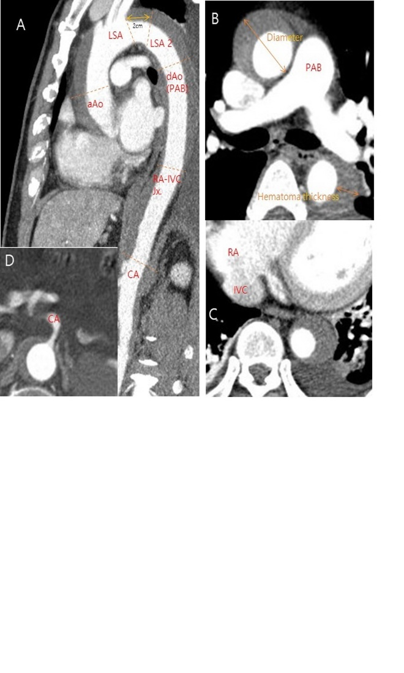
Figure 1. Measurement of diameters and thickness of intramural hematoma at each level of the aorta using computed tomography (CT) scans. (A) Diameters at the LSA and LSA 2 levels were measure in the oblique sagittal planes of CT scans. (B) maximal diameter of descending aorta and hematoma thickness were measured at the level of PAB in the axial planes of CT scans. (C and D) Diameters at the RA-IVC junction and CA levels were also measured in the axial planes of CT scans. aAo: ascending aorta; dAo: descending aorta; LSA: left subclavian artery; LSA 2: 2cm distal to the left subclavian artery; PAB: pulmonary artery bifurcation; IVC-RA Jx.: inferior vena cava-right atrium junction; CA: celiac axis.
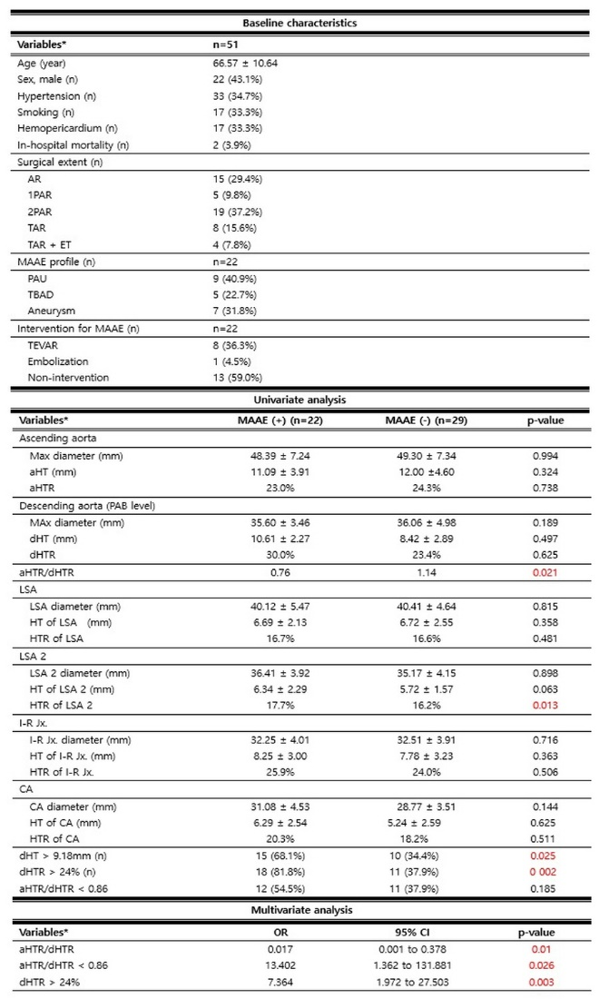
Table 1. Baseline characteristic and Univariate & multivariate analysis according to the occurrence of MAAE after acute type A intramural hematoma surgery. * Value expressed as mean ±standard deviation for continuous data or number (percent) for categorical data. AR: ascending aorta replacement; 1PAR: 1 partial arch replacement; 2PAR: 2 partial arch replacement; TAR: total arch replacement; ET: elephant trunk; MAAE: major adverse aortic event; TEVAR: thoracic endovascular aortic repair; PAU: penetrating aortic ulcer; TBAD: type B aortic dissection; aHT: hematoma thickness of ascending aorta; aHTR: hematoma thickness ratio of ascending aorta; PAB: pulmonary artery bifurcation; dHT: hematoma thickness of descending aorta; dHTR: hematoma thickness ratio of descending aorta; LSA: left subclavian artery; LSA 2: 2cm distal to left subclavian artery; I-R Jx.: inferior vena cava-right atrium junction; CA: celiac axis; OR: odds ratio; CI: confidence interval.

