Table1. Patients’ characteristics
 | Patients (n=64)
Age (years) | 60.8±16.6
Female, n (%) | 17 (26.6)
HTN, n (%) | 32 (50)
DM, n (%) | 16 (25)
CKD, n (%) | 6 (9.4)
CVA Hx., n (%) | 12 (18.8)
MI Hx., n (%) | 3 (4.7)
Aorto-esophageal fistula, n (%) | 14 (21.9)
Aorto-pulmonary fistula, n (%) | 6 (9.4)
Location of aneurysm at native aorta (n=44)
Ascending aorta, n (%) | 6 (13.6)
Aortic arch, n (%) | 11 (25)
Descending aorta, n (%) | 16 (36.4)
Thoracoabdomen, n (%) | 7 (15.9)
Others, n (%) | 3 (6.8)
Type of infection
Mycotic aneurysm, n (%) | 39 (60.9)
Infective aorta without aneurysm, n (%) | 5 (7.8)
Graft infection, n (%) | 20 (31.3)
Emergent operation, n (%) | 19 (29.7)
Remote site infection, n (%) | 26 (40.6)
Previous infective endocarditis, n (%) | 3 (4.7)
Respiratory infection, n (%) | 5 (7.8)
Abdominal infection, n (%) | 6 (9.4)
Mediastinitis, n (%) | 4 (6.3)
Others, n (%) | 8 (12.5)
Organism type
Staphylococcus species, n (%) | 9 (14.1)
Other gram (+) bacteria, n (%) | 8 (12.5)
Pseudomonas species, n (%) | 5 (7.8)
Other gram (-) bacteria, n (%) | 11 (17.2)
Miscellaneous, n (%) | 5 (7.8)
Not detected, n (%) | 26 (40.6)

Table 2. outcome
 | Total (n=64)
Overall duration of intravenous antibiotics usage
< 4weeks, n (%) | 3 (4.7)
4 ≤, ,< 8weeks, n (%) | 30 (46.9)
8 ≤, ,< 12weeks, n (%) | 8 (12.5)
12weeks ≤, n (%)ª | 14 (21.9)
discontinued due to death or transferal, n (%) | 9 (14.1)
PO anti maintenance at discharge, n (%)ª | 28 (43.8)
bleeding, n | 15
stroke, n | 5
wound infection, n | 7
Graft infection, n | 6
30-day mortality, n | 8
Overall mortality, n | 22
a: Tbc medication 4 patients and Q fever 1 patient were included

Table 3. Risk factor analysis for overall death using Cox proportional hazard model
variable | Univariate analysis
variable | Hazard Ratio (95% CI) | P value
Age | 1.01 (0.99 – 1.04) | 0.34
Esophageal fistula | 2.70 (1.13 – 6.45) | 0.03
Pulmonary fistula | 1.45 (0.43 – 4.93) | 0.56
Graft infection* | 1.02 (0.98 – 1.06) | 0.43
Homograft usage | 0.66 (0.27 – 1.62) | 0.36
Culture (+)* | 1.02 (0.96 – 1.08) | 0.49
Emergency | 0.65 (0.24 – 1.78) | 0.41
Primary infection | 1.23 (0.53 – 2.86) | 0.63
* analysis by using Time-dependent Cox regression

Figure 1. Preoperative aortic aneurysm
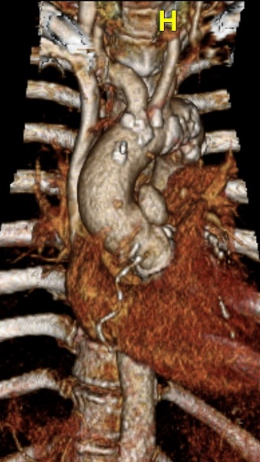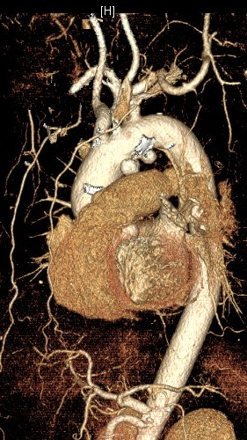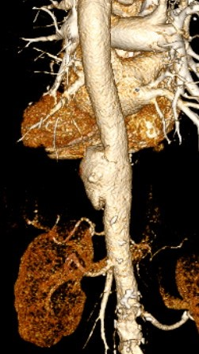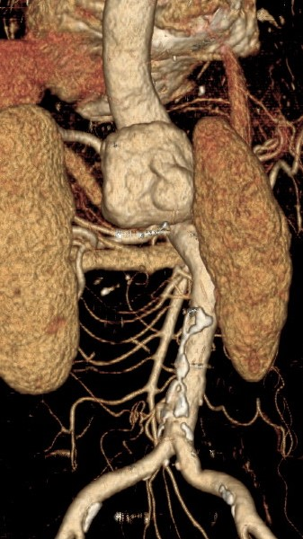
Figure. Kaplan-Meier curve and log rank test; estimated 1 year survival 76.4±6.3 vs. 54.5±13.8 (p=0.02)

