Title: High versus Low Thoracic Aorta Calcium score in Acute type A Intramural Hematoma
[Table]
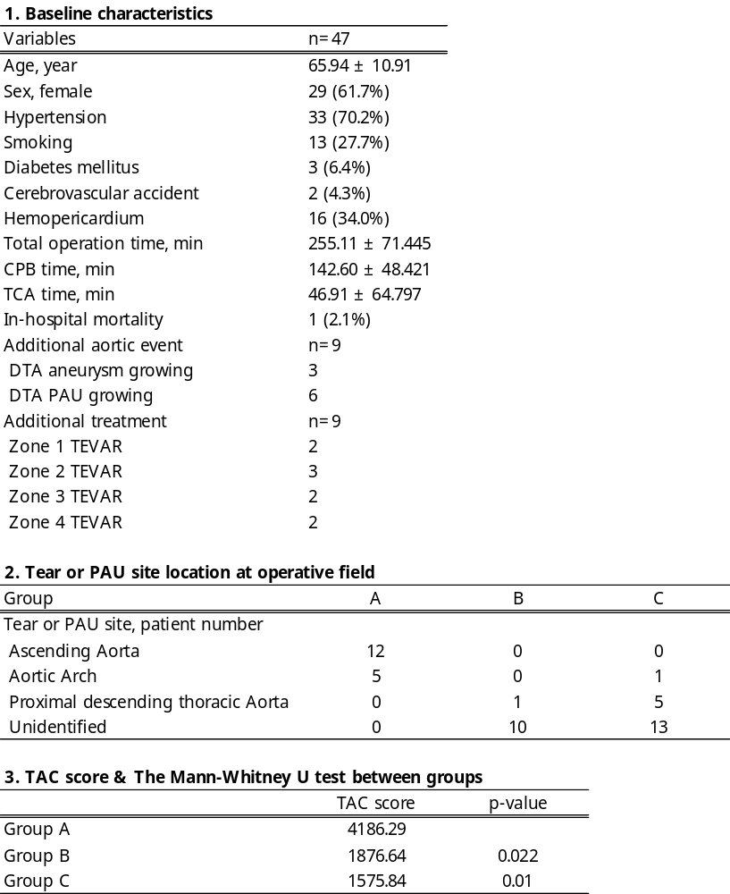

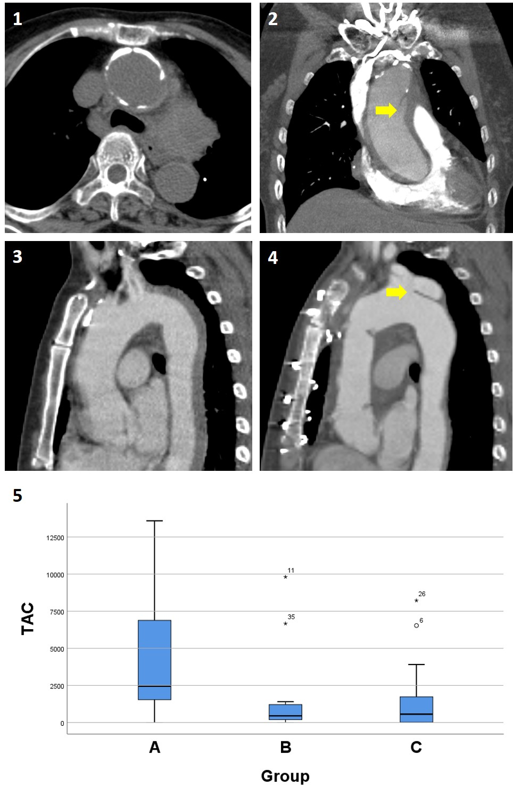
[Figure]

Figure 1 Heavy calcification at intima layer in anterograde ATAIMH
Figure 2 Tear site in anterograde ATAIMH
Figure 3 Not identified tear or PAU site in retrograde ATAIMH
Figure 4 Newly developed PAU in retrograde ATAIMH
Figure 5 TAC scores between 3 groups (A, B & C)

