Title: Outcomes of Prophylactic Endosuture Aneurysm Repair in Aortic Aneurysm with Hostile Landing Zone
[Table]
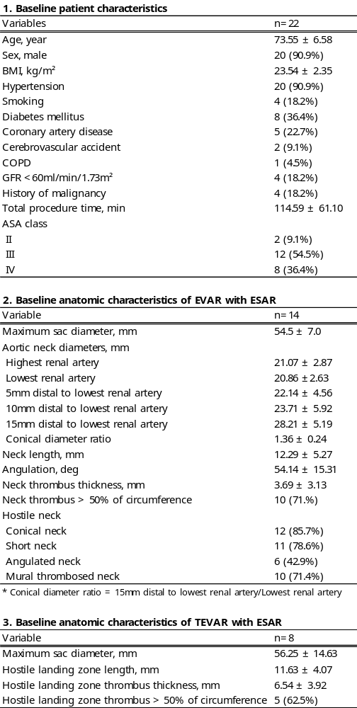
[Figure]
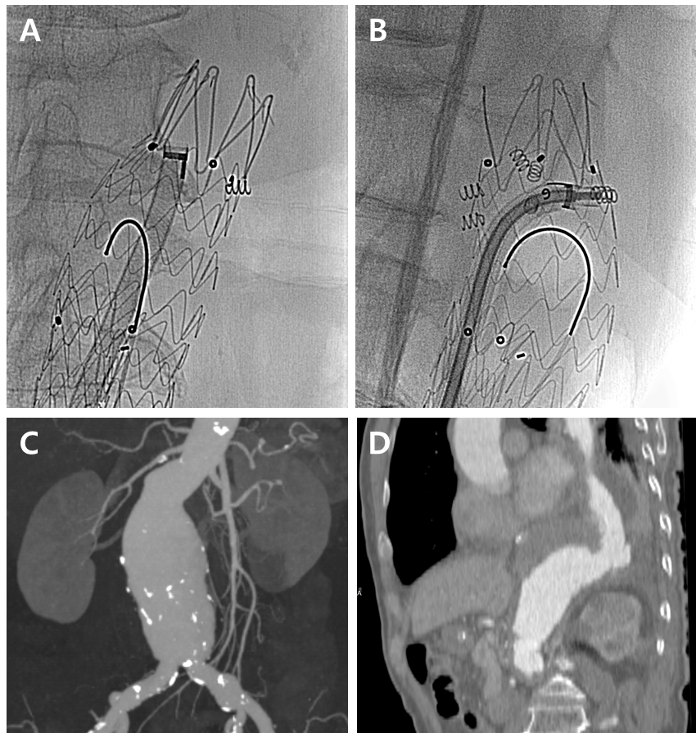
Figure A & B Procedure of Endosuture Aneurysm Repair (EndoAnchor®)
Figure C Abdominal Aorta aneurysm with hostile neck
Figure D Distal descending thoracic Aorta aneurysm with hostile distal landing zone

