Table 1. Patient’s characteristics
No. | Sex | Age  (years) | Diagnosis | Size  (cm) | Approach  (Rt. vs Lt.) or  Subxiphoid | Operation time  (min) | Conversion to  multiport or open | Drain  Removed  (days) | Morbidity | Hospital  Stay(days)
1 | F | 51 | Thymoma AB (A+B2) | 6 | Rt. | 145 | No | 3 |  | 5
2 | F | 55 | Thymoma B3 | 6 | Lt | 188 | No | 3 |  | 4
3 | M | 39 | Thymoma B1+B2 | 6.2 | Rt. | 130 | No | 3 |  | 4
4 | F | 60 | Thymoma A+B2 | 8.5 | Rt. | 192 | No | 3 |  | 3
5 | M | 54 | Thymoma AB(B2+A) | 16 | Subxiphoid | 363 | No | 9 | Prolonged  air leak | 22
6 | F | 60 | Thymic cyst | 5 | Lt. | 190 | No | 2 |  | 7
7 | F | 56 | Thymic cyst | 4.5 | Rt. | 140 | No | 4 |  | 5
8 | M | 68 | Thymic cyst | 5.5 | Subxiphoid | 146 | No | 3 |  | 3
9 | F | 39 | Teratoma | 12 | Subxiphoid | 131 | No | 6 |  | 6
10 | M | 62 | Teratoma | 4.5 | Subxiphoid | 130 | No | 3 |  | 3
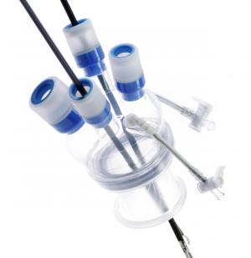
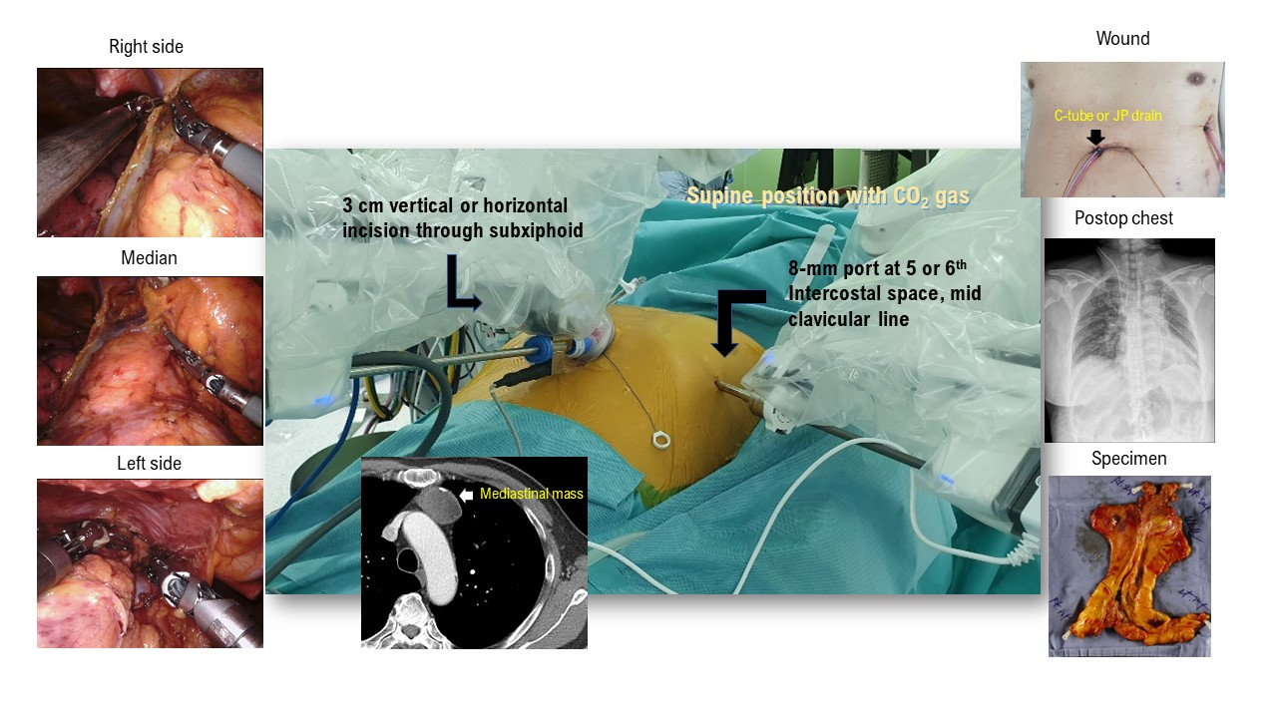
Single port
Figure 1 Two-port approach for robotic mediastinal surgery

