Figure 1. A schematic diagram to describe the definition of parameters. 1. AoD: Aortic area-derived diameter 2. TLD_{max}: Maximal true lumen diameter 4. TL_{area}: True lumen area 5. L-DM: Length of dissection membrane 6. L-TLB_{ext}: Length of external true lumen boundary 7. L-FLB_{ext}: Length of external false lumen boundary. T, True lumen; F, False lumen.
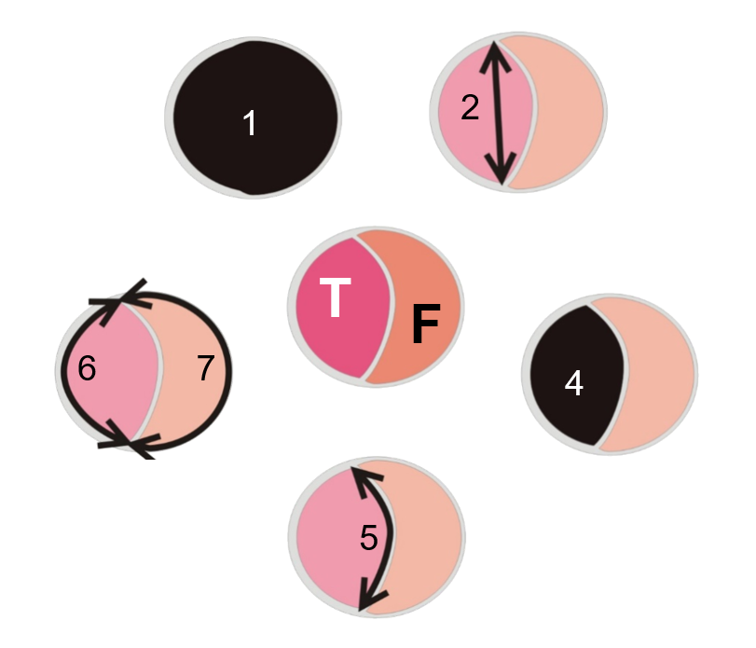

Figure 2. Changes in aortic geometry after the complete remodeling of the proximal descending thoracic aorta. AoD, aortic area-derived diameter; TLD_{max}, maximal true lumen diameter; AoD_{Rylski}, estimated pre-dissection aortic diameter using the Rylski factor; TL_{area}, True lumen area; L-DM, length of dissection membrane; L-FLB_{ext}, length of external false lumen boundary.
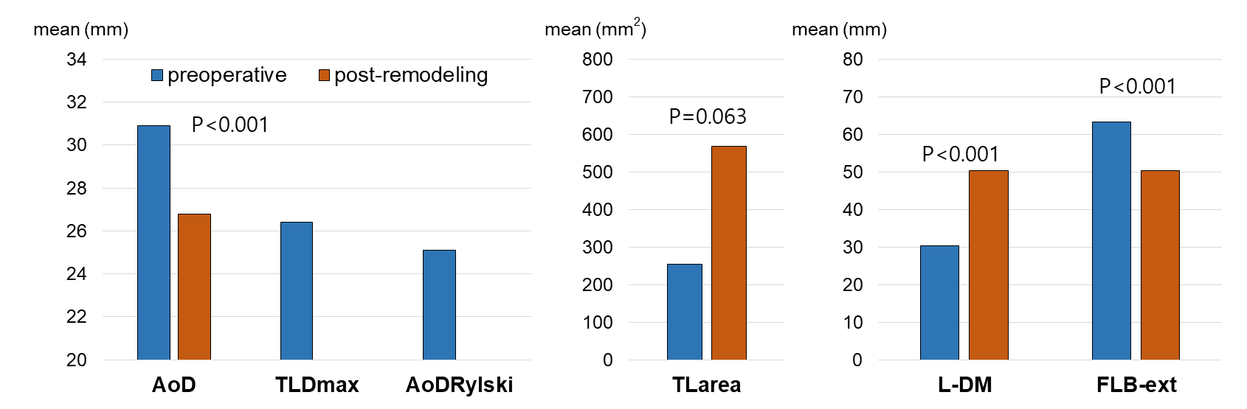

Figure 3. Bland-Altman plots for (A) post-remodeling aortic diameter (reference) and preoperative maximal true lumen diameter and (B) post-remodeling aortic diameter (reference) and estimated pre-dissection aortic diameter using the Rylski factor. AoD, aortic area-derived diameter; TLD_{max}, maximal true lumen diameter; AoD_{Rylski}, estimated pre-dissection aortic diameter using the Rylski factor; L-FLB_{ext}, length of external false lumen boundary.
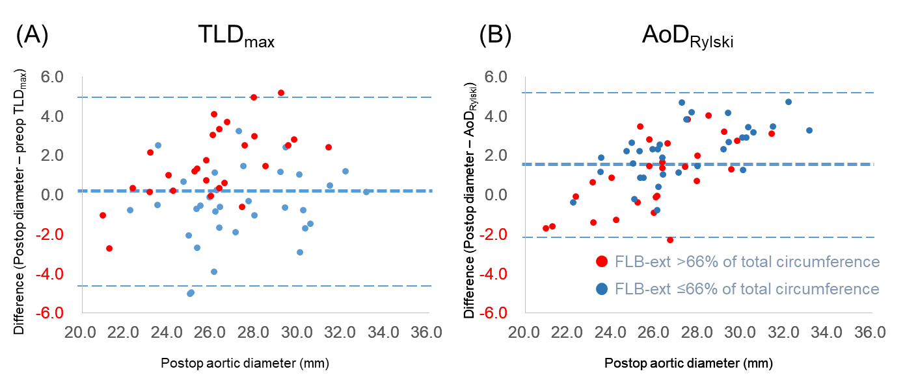

Figure 4. Scatter plots of TLD_{max} and AoD_{Rylski} expressed according to the discrepancy with post-remodeling AoD. TLD_{max}, maximal true lumen diameter; AoD_{Rylski}, estimated pre-dissection aortic diameter using the Rylski factor; AoD, aortic area-derived diameter.

Table 1. Baseline characteristics and operative details of the study patients.
Characteristics | Value
Demographics
Age (year) | 59.8 ± 12.5
Men, n (%) | 31 (51.7)
Preoperative malperfusion, n (%)
Brain | 8 (13.3)
Coronary | 3 (5)
Upper extremity | 1 (1.7)
Spinal cord | 1 (1.7)
Visceral | 3 (5)
Renal | 2 (3.3)
Lower extremity | 4 (6.6)
All (any of above) | 21 (35)
Type of operation, n (%)
Ascending aorta replacement | 15 (25)
Partial arch replacement | 16 (26.7)
Conventional total arch replacement | 3 (5)
Total arch replacement with a short elephant trunk | 26 (43.3)
Computed tomography data
The interval between surgery and reviewed CT (months) | 16.1 ± 9.0
Continuous variables are presented as the means ± standard deviations. CT, computed tomography.

Table 2. Changes of parameters in acute type I aortic dissection after the complete remodeling of the false lumen in descending thoracic aorta.
Parameters | Preoperative | Post-remodeling | P-value
AoD (mm) | 30.9 ± 2.5 | 26.8 ± 2.7 | <0.001
TLD_{max} (mm) | 26.4 ± 3.1 | - | -
AoD_{Rylski} (mm) | 25.1 ± 2.0 | - | -
TL_{area} (mm²) | 254.4 ± 92.5 | 567.8 ± 113.6 | 0.063
L-DM (mm) | 30.3 ± 3.9 | 50.3 ± 7.7 | <0.001
L-TLB_{ext} (mm) | 33.8 ± 6.9 | 33.8 ± 6.9 | -
L-FLB_{ext} (mm) | 63.2 ± 8.5 | 50.3 ± 7.7 | <0.001
All parameters are presented as the means ± standard deviations. AoD, aortic area-derived diameter; TLD_{max}, maximal true lumen diameter; AoD_{Rylski}, estimated pre-dissection aortic diameter using Rylski factor (1.23); TL_{area}, True lumen area; L-DM, length of dissection membrane; L-TLB_{ext}, length of external true lumen boundary; L-FLB_{ext}, length of external false lumen boundary.

Table 3. Comparison of the difference between the preoperative parameters and the post-remodeling aortic diameter between two groups according to the extent of circumferential dissection.
 | Group 1 (n=33)  L-FLB_{ext} ≤ 66% of total circumference | Group 2 (n=27)  L-FLB_{ext} > 66% of total circumference | P-value
Difference (TLD_{max} – Post-remodeling AoD) | 0.6 ± 1.9 | -1.6 ± 1.8 | <0.001
Difference (AoD_{Rylski} – Post-remodeling AoD) | -2.2 ± 1.4 | -1.0 ± 1.8 | 0.007
TLD_{max}, maximal true lumen diameter; AoD, aortic area-derived diameter; AoD_{Rylski}, estimated pre-dissection aortic diameter using Rylski factor (1.23); L-FLB_{ext}, length of external false lumen boundary.

