Figure 1. The flow chart of this study.
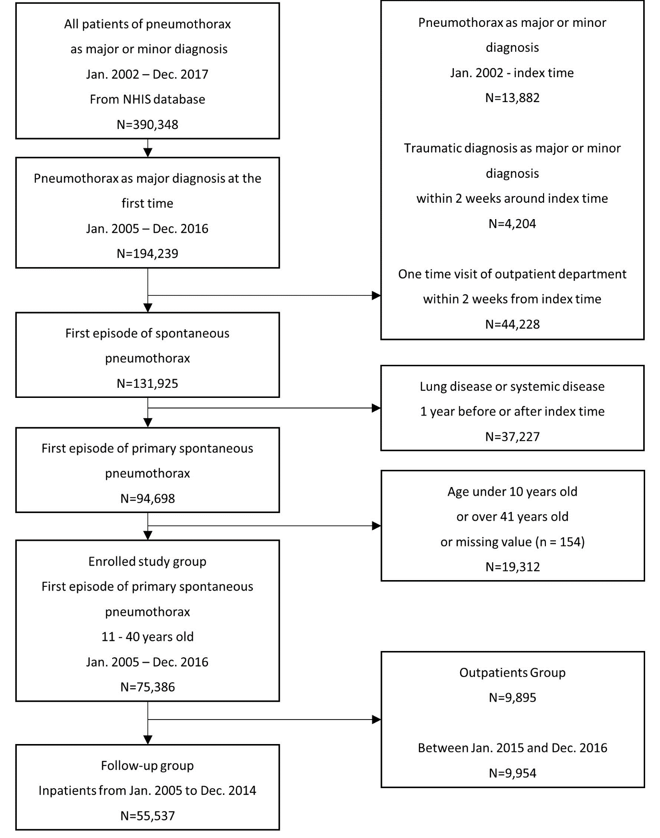

Figure 2. (A) The average annual incidence rate of the first episode of primary spontaneous pneumothorax stratified by sex and age. (B) The annual incidence rate of the first episode of primary spontaneous pneumothorax between 2005 and 2016 (APC 2.6%, p for trend=0.0=16).
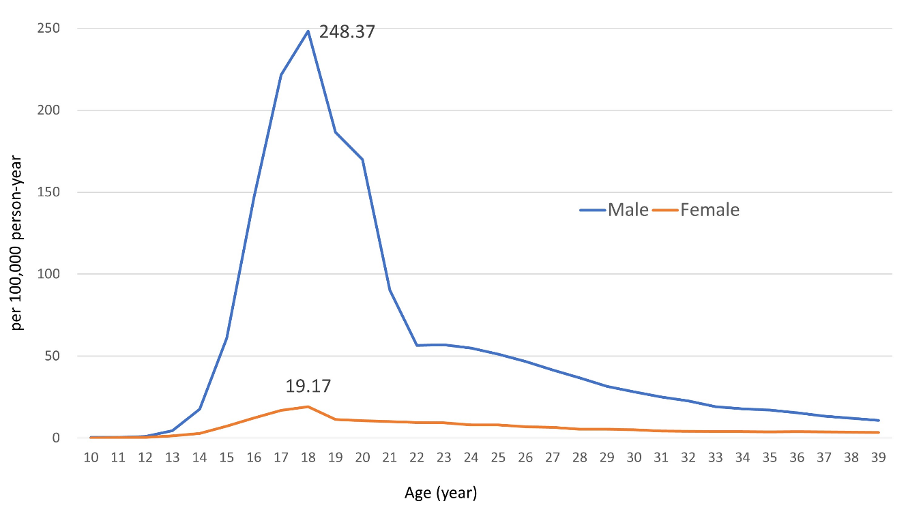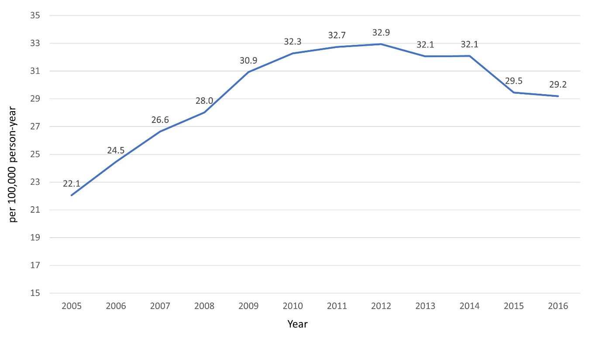

Figure 3. (A) The annual proportion of surgical treatment in hospitalized patients with the first episode of primary spontaneous pneumothorax between 2005 and 2016 (APC = 0.9%, p for trend <0.001). (B) The annual proportion of thoracoscopy in patients received surgical treatment for with the first episode of primary spontaneous pneumothorax between 2007 and 2016 (APC = 1.0%, p for trend <0.001).
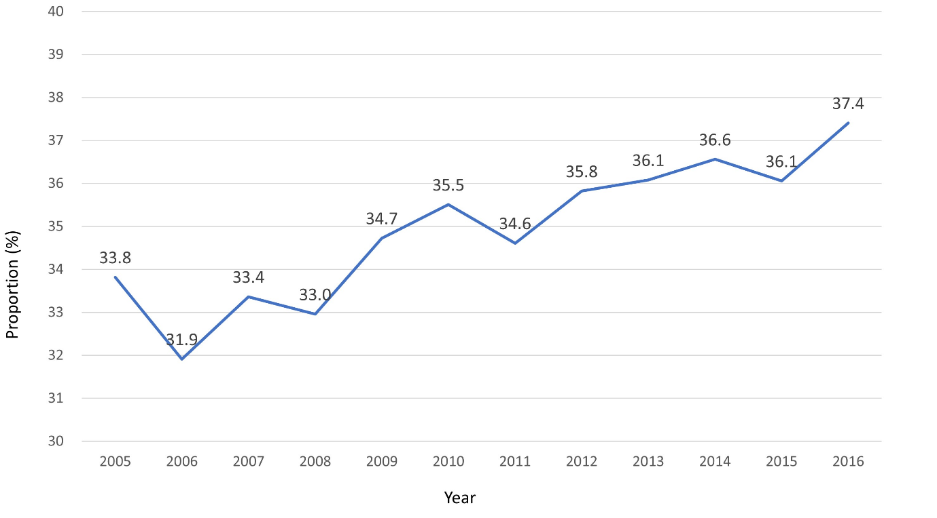
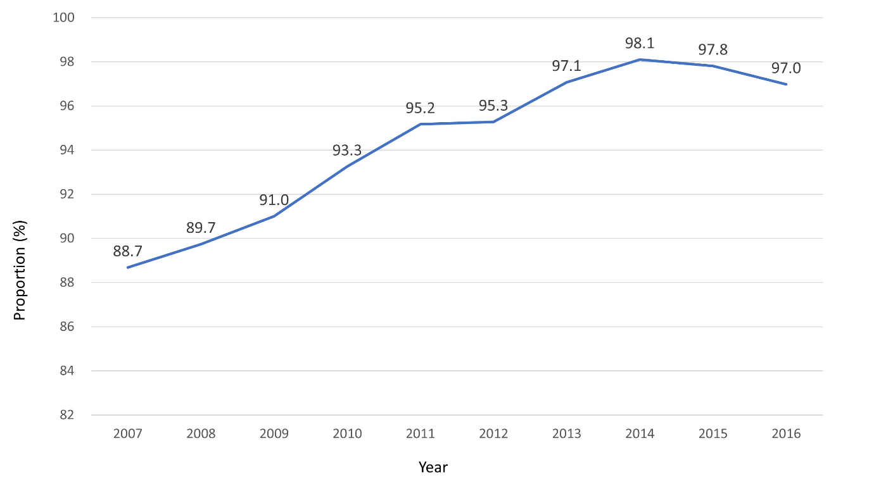
Table 1. Characteristics of patients with the first episode of primary spontaneous pneumothorax aged from 10 to 39 years old between 2005 and 2016 in Korea.
Characteristics | N=74,630
Age (years), median (IQRs) | 19 (17-26)
Age ranged, n (%)
10-14 | 1,174 (1.6%)
15-19 | 38,173 (51.1%)
20-24 | 13,692 (18.3%)
25-29 | 10,591 (14.2%)
30-34 | 6,505 (8.7%)
35-39 | 4,495 (6.0%)
Sex, n (%)
Male | 66,786 (89.5%)
Female | 7,844 (10.5%)
Initial strategy, n (%)
Inpatient | 64,389 (86.9%)
Outpatient | 9,791 (13.1%)

Table 2. Characteristics and management of outpatient and inpatient group of patients with the first episode of primary spontaneous pneumothorax aged from 10 to 39 years old between 2005 and 2016 in Korea.
Outpatient group | N = 9,791
Age (years), median (IQRs) | 19 (17-25)
Male, n (%) | 8,633 (88.2%)
Treatment
Observation | 9594 (98.0%)
Thoracentesis | 67 (0.7%)
Closed thoracostomy | 131 (1.3%)
Admission within 1 week | 2553 (26.1%)
Inpatient group | N = 64,839
Age (years), median (IQRs) | 19 (17-26)
Male, n (%) | 58,513 (89.7%)
Length of stay (days), median (IQRs) | 6 (4-9)
Intensive care unit, n (%) | 780 (1.2%)
Non-surgical group | 42,189 (65.1%)
Surgical group | 22,650 (34.9%)
Inhospital mortality | 12 (0.02%)

Table 3. Characteristics and management of non-surgical and surgical group among inpatients with the first episode of primary spontaneous pneumothorax aged from 10 to 39 years old between 2005 and 2016 in Korea.
Non-surgical group | N = 42,189
Age (years), median (IQRs) | 19 (17-26)
Male, n (%) | 37,461 (88.8%)
Length of stay (days), median (IQRs) | 5 (4-7)
Intensive care unit, n (%) | 205 (0.5%)
Treatment
Observation | 11,232 (26.6%)
Thoracentesis | 372 (0.9%)
Closed thoracostomy | 30,585 (72.5%)
Inhospital mortality | 12 (0.03%)
Readmission* | 12,977 (36.1%)
Surgical group | N = 22,650
Age (years), median (IQRs) | 19 (17-25)
Male, n (%) | 20,692 (91.4%)
Length of stay (days), median (IQRs) | 8 (6-11)
Intensive care unit, n (%) | 575 (2.5%)
Treatment
Bullectomy or wedge resection | 22,508 (99.4%)
Other type of lung resection | 93 (0.4%)
Talc pleurodesis | 151 (0.7%)
Thoracoscopic surgery** | 18,506 (94.4%)
Inhospital mortality | 0 (0%)
Readmission* | 4,403 (23.1%)
*Readmission rate was calculated for 54,993 inpatients between 2005 and 2014.
** Thoracoscoy claim data was available from July 2006. The proportion of thoracoscopic surgery was calculated for 19,607 patients with surgery between 2007 and 2016.

Table S1. The ICD-10 code and number of patients with each underlying lung disease and systemic disease.
Disease | N (%) | ICD-10 code
COPD* | 26596 (71.4%) | J43, J44
Bronchiectasis | 3436 (9.2%) | J47
Pulmonary tuberculosis | 12804 (34.4%) | A150, A151, A152, A153, A155, A156, A157, A158, A159, A160, A161, A162,
 |  | A164, A165, A167, A168, A169, B909
Lung cancer | 4598 (12.4%) | C340, C341, C342, C343, C348, C349, C780, D143, D381, D382, Z851, Z852
Sarcoidosis | 21 (0.06%) | D860, D861, D862, D863, D868, D869
Cystic fibrosis | 299 (0.8%) | E840, E849
Interstitial lung disease | 1885 (5.1%) | J700, J701, J703, J704, J708, J709, J840, J841, J848, J849, J961, J991, J998
Endometriosis | 313 (0.8%) | N800, N801, N802, N803, N804, N805, N806, N808, N809
Pneumocystis pneumonia | 26 (0.07%) | B206, B59
Tuberous sclerosis | 0 (0%) | Q581
Ankylosing spondylitis | 526 (1.4%) | M081, M45
Scleroderma | 11 (0.03%) | L940, L941
Ehlers-Danlos syndrome | 3 (0.008%) | Q796
Marfan syndrome | 121 (0.3%) | Q874
Langerhans cell histiocytosis | 26 (0.07%) | C960, C9608, C965, C966, D761, D763
Cystic lung disease | 291 (0.8%) | J9848, Q330
Amyloidosis | 9 (0.02%) | E85
* COPD : Chronic obstructive pulmonary disease
Table S2. The number of patients, the number of population, and the annual incidence rate (IR) stratified by age groups and sex between 2005 and 2016.
 | The number of patients |  |  | The number of populations* |  |  | Incidence rate (IR)** |  |  | Ratio
Age | Male | Female | Total | Male | Female | Total | Male | Female | Total | male to female IR
0 | 338 | 146 | 484 | 224,455 | 211,415 | 435,870 | 12.5 | 5.8 | 9.3 | 2.2
1-4 | 22 | 8 | 30 | 973,019 | 911,271 | 1,884,290 | 0.2 | 0.1 | 0.1 | 2.6
5-9 | 31 | 17 | 48 | 1,375,980 | 1,270,659 | 2,646,639 | 0.2 | 0.1 | 0.2 | 1.7
10-14 | 987 | 187 | 1,174 | 1,643,177 | 1,484,446 | 3,127,622 | 5.0 | 1.0 | 3.1 | 4.8
15-19 | 35,621 | 2,552 | 38,173 | 1,720,460$ | 1,582,930 | 3,303,390$ | 172.5 | 13.4 | 96.3 | 12.8
20-24 | 11,866 | 1,826 | 13,692 | 1,330,852$ | 1,608,286 | 2,939,138$ | 74.3 | 9.5 | 38.8 | 7.9
25-29 | 9,241 | 1,350 | 10,591 | 1,859,943 | 1,752,477 | 3,612,420 | 41.4 | 6.4 | 24.4 | 6.4
30-34 | 5,504 | 1,001 | 6,505 | 2,041,276 | 1,958,676 | 3,999,951 | 22.5 | 4.3 | 13.6 | 5.3
35-39 | 3,567 | 928 | 4,495 | 2,168,279 | 2,091,915 | 4,260,194 | 13.7 | 3.7 | 8.8 | 3.7
40-44 | 2,548 | 886 | 3,434 | 2,228,715 | 2,145,976 | 4,374,691 | 9.5 | 3.4 | 6.5 | 2.8
45-49 | 2,180 | 804 | 2,984 | 2,169,723 | 2,101,431 | 4,271,154 | 8.4 | 3.2 | 5.8 | 2.6
50-54 | 2,048 | 659 | 2,707 | 1,930,387 | 1,897,068 | 3,827,455 | 8.8 | 2.9 | 5.9 | 3.1
55-59 | 1,816 | 514 | 2,330 | 1,501,733 | 1,515,144 | 3,016,877 | 10.1 | 2.8 | 6.4 | 3.6
60-64 | 1,555 | 408 | 1,963 | 1,111,234 | 1,175,001 | 2,286,236 | 11.7 | 2.9 | 7.2 | 4.0
65-69 | 1,369 | 387 | 1,756 | 889,031 | 1,024,090 | 1,913,121 | 12.8 | 3.1 | 7.6 | 4.1
70-74 | 1,211 | 417 | 1,628 | 663,815 | 881,374 | 1,545,189 | 15.2 | 3.9 | 8.8 | 3.9
75-79 | 898 | 357 | 1,255 | 398,646 | 653,119 | 1,051,766 | 18.8 | 4.6 | 9.9 | 4.1
80-84 | 457 | 273 | 730 | 190,861 | 403,826 | 594,687 | 20.0 | 5.6 | 10.2 | 3.5
85-89 | 225 | 146 | 371 | 72,896 | 197,285 | 270,182 | 25.7 | 6.2 | 11.4 | 4.2
90- | 95 | 98 | 193 | 23,236 | 85,412 | 108,648 | 34.1 | 9.6 | 14.8 | 3.6
Total | 81,579 | 12,964 | 94,543% | 24,517,718$ | 24,951,801 | 49,469,520$ | 27.7 | 4.3 | 15.9 | 6.4
* Average mean values of the population from 2005 and 2016, which was 12 years of study period.
** Incidence rate is presented as per 100,000 person-years. IR = (the number of patients/the number of population/12) X 100,000.
$ The population was adjusted according to the number of soldiers enlisted.
%The total number of first episode of primary spontaneous pneumothorax in whole population was 94,698 in Figure 1. The data of age and sex was missed in 155 patients.

Table S3. The number of patients according to surgical procedure.
Type of surgical procedure | N = 22,650
Bullectomy, n (%) | 1,766 (7.8%)
Bullectomy and wedge resection, n (%) | 19 (0.08%)
Wedge resection, n (%) | 20,723 (91.5%)
Wedge resection and segmentectomy, n (%) | 12 (0.05%)
Segmentectomy, n (%) | 74 (0.3%)
Segmentectomy and lobectomy, n (%) | 1 (0.00%)
Lobectomy, n (%) | 6 (0.02%)
Talc pleurodesis without lung resection, n (%) | 49 (0.2%)
Talc pleurodesis with lung resection, n (%) | 102 (0.5%)

Table S4. The number of patients with the first episode of primary spontaneous pneumothorax between 10 and 39 years old, the number of population, and the annual incidence rate (IR) stratified by age and sex between 2005 and 2016.
 | The number of patients |  |  |  |  | The number of populations* |  |  | Incidence rate (IR)** |  |  |  |  | Ratio
Age | Male | Female |  | Total |  | Male | Female | Total | Male | Female |  | Total |  | male to female IR
10 | 13 |  | 5 |  | 18 | 305,452 | 278,498 | 583,949 | 0.4 | 0.1 |  | 0.3 |  | 2.4
11 | 17 |  | 7 |  | 24 | 318,050 | 288,326 | 606,376 | 0.4 | 0.2 |  | 0.3 |  | 2.2
12 | 37 |  | 15 |  | 52 | 330,245 | 298,032 | 628,277 | 0.9 | 0.4 |  | 0.7 |  | 2.2
13 | 181 |  | 50 |  | 231 | 340,661 | 306,590 | 647,251 | 4.4 | 1.4 |  | 3.0 |  | 3.3
14 | 739 |  | 110 |  | 849 | 348,769 | 313,000 | 661,769 | 17.7 | 2.9 |  | 10.7 |  | 6.0
15 | 2,587 |  | 280 |  | 2,867 | 353,776 | 316,718 | 670,494 | 60.9 | 7.4 |  | 35.6 |  | 8.3
16 | 6,267 |  | 469 |  | 6,736 | 355,007 | 317,430 | 672,436 | 147.1 | 12.3 |  | 83.5 |  | 11.9
17 | 9,425 |  | 643 |  | 10,068 | 354,298 | 316,845 | 671,144 | 221.7 | 16.9 |  | 125.0 |  | 13.1
18 | 10,535 |  | 728 |  | 11,263 | 353,472 | 316,407 | 669,879 | 248.4 | 19.2 |  | 140.1 |  | 13.0
19 | 6,807 |  | 432 |  | 7,239 | 303,907$ | 315,530 | 619,437$ | 186.7 | 11.4 |  | 97.4 |  | 16.4
20 | 3,293 |  | 404 |  | 3,697 | 161,544$ | 314,757 | 476,301$ | 169.9 | 10.7 |  | 64.7 |  | 15.9
21 | 1,842 |  | 380 |  | 2,222 | 169,894$ | 315,694 | 485,588$ | 90.4 | 10.0 |  | 38.1 |  | 9.0
22 | 2,043 |  | 363 |  | 2,406 | 301,041$ | 319,740 | 620,781$ | 56.6 | 9.5 |  | 32.3 |  | 6.0
23 | 2,328 |  | 362 |  | 2,690 | 340,620$ | 325,905 | 666,525$ | 57.0 | 9.3 |  | 33.6 |  | 6.2
24 | 2,360 |  | 317 |  | 2,677 | 357,753$ | 332,190 | 689,943$ | 55.0 | 8.0 |  | 32.3 |  | 6.9
25 | 2,232 |  | 324 |  | 2,556 | 363,780 | 338,403 | 702,183 | 51.1 | 8.0 |  | 30.3 |  | 6.4
26 | 2,057 |  | 283 |  | 2,340 | 367,126 | 343,871 | 710,997 | 46.7 | 6.9 |  | 27.4 |  | 6.8
27 | 1,848 |  | 273 |  | 2,121 | 370,975 | 349,747 | 720,721 | 41.5 | 6.5 |  | 24.5 |  | 6.4
28 | 1,658 |  | 233 |  | 1,891 | 376,060 | 356,693 | 732,753 | 36.7 | 5.4 |  | 21.5 |  | 6.7
29 | 1,446 |  | 237 |  | 1,683 | 382,003 | 363,763 | 745,766 | 31.5 | 5.4 |  | 18.8 |  | 5.8
30 | 1,321 |  | 223 |  | 1,544 | 390,087 | 372,667 | 762,754 | 28.2 | 5.0 |  | 16.9 |  | 5.7
31 | 1,198 |  | 202 |  | 1,400 | 399,475 | 383,036 | 782,511 | 25.0 | 4.4 |  | 14.9 |  | 5.7
32 | 1,110 |  | 198 |  | 1,308 | 409,137 | 393,164 | 802,301 | 22.6 | 4.2 |  | 13.6 |  | 5.4
33 | 963 |  | 187 |  | 1,150 | 418,212 | 401,933 | 820,145 | 19.2 | 3.9 |  | 11.7 |  | 4.9
34 | 912 |  | 191 |  | 1,103 | 424,366 | 407,875 | 832,241 | 17.9 | 3.9 |  | 11.0 |  | 4.6
35 | 878 |  | 187 |  | 1,065 | 427,962 | 411,725 | 839,687 | 17.1 | 3.8 |  | 10.6 |  | 4.5
36 | 796 |  | 197 |  | 993 | 431,198 | 415,680 | 846,878 | 15.4 | 3.9 |  | 9.8 |  | 3.9
37 | 696 |  | 193 |  | 889 | 433,313 | 418,746 | 852,059 | 13.4 | 3.8 |  | 8.7 |  | 3.5
38 | 630 |  | 178 |  | 808 | 435,998 | 421,354 | 857,353 | 12.0 | 3.5 |  | 7.9 |  | 3.4
39 | 567 |  | 173 |  | 740 | 439,807 | 424,409 | 864,217 | 10.7 | 3.4 |  | 7.1 |  | 3.2
Total | 66,786 |  | 7,844 |  | 74,630 | 10,763,987 | 10,478,729 | 21,242,715 | 51.7 |  | 6.2 |  | 29.3 | 8.3
* Average mean values of the population from 2005 and 2016, which was 12 years of study period.
** Incidence rate is presented as per 100,000 person-years. IR = (the number of patients/the number of population/12) X 100,000.
$ The population was adjusted according to the number of soldiers enlisted.

Table S5. The annual incidence rate of the first episode of primary spontaneous pneumothorax stratified by sex between 2005 and 2016
 | Incidence rate*
Year | Male | Female | Total
2005 | 39.1 | 4.6 | 22.1
2006 | 43.2 | 5.2 | 24.5
2007 | 46.9 | 5.8 | 26.6
2008 | 49.1 | 6.3 | 28.0
2009 | 54.3 | 6.9 | 30.9
2010 | 56.7 | 7.3 | 32.3
2011 | 57.8 | 7.1 | 32.7
2012 | 58.3 | 7.1 | 32.9
2013 | 57.0 | 6.5 | 32.1
2014 | 57.4 | 6.2 | 32.1
2015 | 52.1 | 6.3 | 29.5
2016 | 52.0 | 5.8 | 29.2
* Incidence rate is presented as per 100,000 person-years

Table S6. The number of admission in outpatients group by day after initial visit.
Day* | The number of patients | % | The cumulative number | Cumulative %
2 | 1,053 | 10.8 | 1,053 | 10.8
3 | 610 | 6.2 | 1,663 | 17.0
4 | 338 | 3.5 | 2,001 | 20.4
5 | 226 | 2.3 | 2,227 | 22.7
6 | 167 | 1.7 | 2,394 | 24.5
7 | 159 | 1.6 | 2,553 | 26.1
8 | 94 | 1.0 | 2,647 | 27.0
9 | 60 | 0.6 | 2,707 | 27.6
10 | 63 | 0.6 | 2,770 | 28.3
11 | 59 | 0.6 | 2,829 | 28.9
12 | 46 | 0.5 | 2,875 | 29.4
13 | 40 | 0.4 | 2,915 | 29.8
14 | 59 | 0.6 | 2,974 | 30.4
15 | 17 | 0.2 | 2,991 | 30.5
16 | 22 | 0.2 | 3,013 | 30.8
17 | 23 | 0.2 | 3,036 | 31.0
18 | 12 | 0.1 | 3,048 | 31.1
19 | 14 | 0.1 | 3,062 | 31.3
20 | 16 | 0.2 | 3,078 | 31.4
21 | 18 | 0.2 | 3,096 | 31.6
22 | 7 | 0.1 | 3,103 | 31.7
23 | 10 | 0.1 | 3,113 | 31.8
24 | 13 | 0.1 | 3,126 | 31.9
25 | 9 | 0.1 | 3,135 | 32.0
26 | 8 | 0.1 | 3,143 | 32.1
27 | 12 | 0.1 | 3,155 | 32.2
28 | 6 | 0.1 | 3,161 | 32.3
29 | 10 | 0.1 | 3,171 | 32.4
30 | 6 | 0.1 | 3,177 | 32.4
* The day of admission after initial visit of outpatients clinics or emergency room. The 0 or 1 day of admission was regarded as initial hospitalization and classified as inpatients group.

