Table 1. Incidence of PPC by the quintiles of FEV1 %pred and DLco %pred in patients with esophageal cancer who underwent esophagectomy 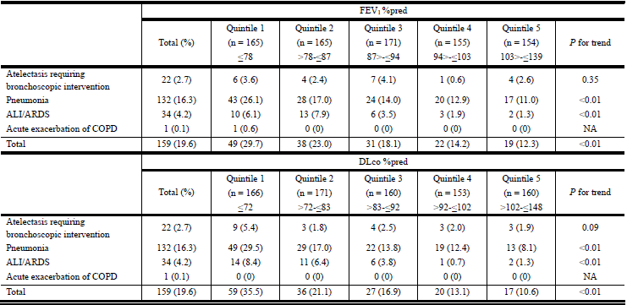
PPC: postoperative pulmonary complication; FEV1, forced expiratory volume in 1 second; %pred: %predicted; DLco: diffusing capacity of the lung for carbon monoxide; Quintile 1: the lowest quintile; Quintile 5: the top quintile; ALI: acute lung injury; ARDS: acute respiratory distress syndrome; COPD: chronic obstructive pulmonary disease.

Table 2. The relative risk for PPC comparing the low lung function group and the high lung function group using different cutoffs in patients with esophageal cancer who underwent esophagectomy
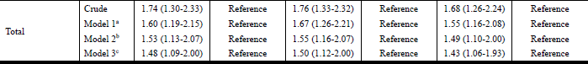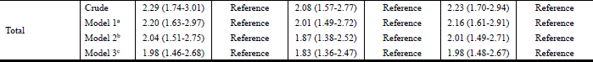
Model 1: adjusted for age, sex, body mass index, and smoking status (never and ever). Model 2: adjusted for variables in model 1, chronic pulmonary disease, cardiovascular disease, and albumin. Model 3: adjusted for variables in model 2, pathologic stage (I, II, and III), tumor location (cervical/upper thoracic, middle thoracic, and lower thoracic/esophagogastric junction), type of surgery (open thoracotomy, video-assisted thoracoscopic, and robotic surgery), lymph node dissection (two-field or less and three-field), and operation time.
PPC: postoperative pulmonary complication; FEV1: forced expiratory volume in 1 second; %pred: %predicted; Quintile 1: the lowest quintile; Quintile 5: the top quintile; ALI: acute lung injury; ARDS: acute respiratory distress syndrome; DLco: diffusing capacity of the lung for carbon monoxide.

