Central image
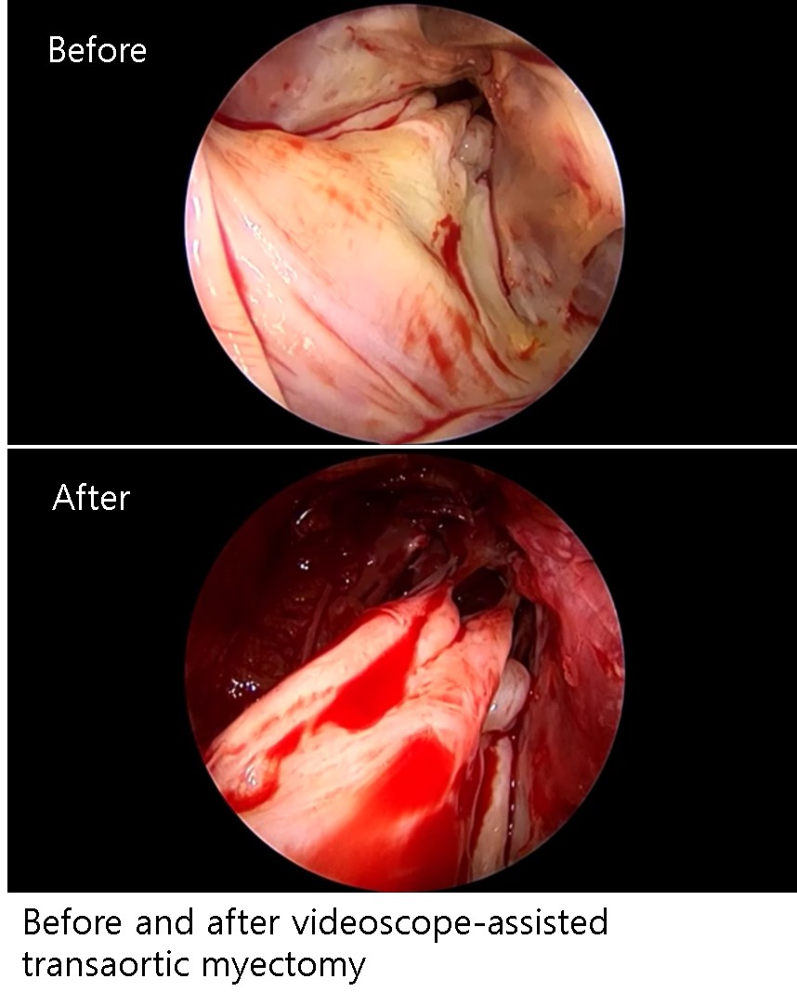
Characteristics
Age | 44.7 ± 11.8
Gender
Female | 3 (30%)
Male | 7 (7%)
BSA (m²/kg) | 1.76 ± 0.23
NYHA
<III | 0 (0%)
≥III | 10 (10%)
Peak Pressure gradient (mmHg)
Resting | 58 ± 43
Valsalva | 103 ± 66
MR grade
<3 | 5 (50%)
≥3 | 5 (50%)
Indication for VATAM
Midventricular septal resection | 7 (70%)
Abnormal papillary muscle resection | 4 (40%)
Abnormal chordae resection | 3 (30%)
Diffuse hypertrophy | 3 (30%)
Thick papillary muscle shaving | 1 (10%)
Table 1

Values are expressed as mean ± standard deviation or number (%)
BSA, body surface area; NYHA, New York Heart Association; MR, mitral regurgitation; VATAM, videoscope-assisted transaortic myectomy

Table 2. Operative and postoperative data
Pump time (minutes) | 126 ± 40
Repeated bypass | 3 (30%)
Hospitalization period (days) | 13.5 ± 2.0
Mitral regurgitation grade
<3 | 10 (10%)
≥3 | 0 (0%)
Pressure gradient (mmHg) | 18.9 ± 14.0
NYHA
<III | 10 (10%)
≥III | 0 (0%)
Values are expressed as mean ± standard deviation or number (%)
NYHA, New York Heart Association

