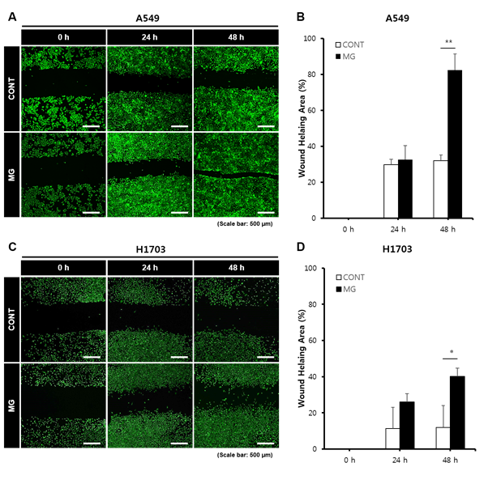

Fig. 1. Wound healing analysis of A549 and H1703 cells on CONT and MG. Migration potential of A549 cells in wound healing assay (A). Calculated wound healing areas in A549 cells (B). Migration potential of H1703 cells in wound healing assay (C). Calculated wound healing areas in H1703 (D) (*p < 0.05, **p < 0.01).

