Table 1. Overall demographics, injury location, outcomes
Patients characteristics (n=40)
Male gender, n (%) | 37(92.5)
Age, y, median[IQR] | 49[38, 57.5]
Trauma mechanism (Fall/TA), n (%) | Fall 13(32.5)  TA 27(67.5)
SBP at ED(mmHg), median[IQR] | 100[80, 117]
ISS, median[IQR] | 33[29, 41]
TRISS, median[IQR] | 0.86[0.4,0.94]
BTAI site, n (%) Arch  Isthmus  Descending | 4(10)  34(85)  9(22.5)
BTAI grade, n (%) I~II  III  IV | 3(7.5)  31(77.5)  6(15)
Aorta size, mm ,median[IQR] | 24.07[22.42, 27.66]
ER admission to treatment, min, (median[IQR]) | 640[310, 1946]
Concomitant or pre-intervention, n (%) | 15(44.1)
Hospital LOS, d, median[IQR] | 33[19.50, 58.50]
ICU LOS, d, median[IQR] | 6.00[3.75, 16.75]
Ventilator days, median[IQR] | 2.50 [1.00, 7.50]
Discharge to home, n (%)  Rehab | 5(12.5)  32(80.0)
FU duration, month, median[IQR] | 21.14[5.26, 32.04]
Mortality, n (%) | 3(7.5)
ED, emergency department; LOS, length of stay; SBP, systolic blood pressure.
BTAI, blunt traumatic aortic injury

Table 2. Comparison open and endovascular repair
 | TEVAR(n=17) | Open(n=16) | p-value
Age, y, median[IQR] | 55[49,62] | 43[26.75,49.0] | 0.002
SBP at ED(mmHg), median[IQR] | 90[80,110] | 105[87.5,115.5] | 0.477
ISS, median[IQR] | 33[29,41] | 34.5[29,39.25] | 0.857
TRISS, median[IQR] | 0.85[0.31,0.88] | 0.9[0.59,0.96] | 0.087
BTAI site, n (%) Arch  Isthmus  Descending | 0  14(82.2)  4(23.5) | 1(6.2)  15(93.8)  3(13.8) | 0.485  0.601  1.0
BTAI grade, n (%) I~II  III  IV | 0(0)  15(88.2)  2(11.8) | 0(0)  12(75)  4(25) | 0.398
Aorta size(mm), median[IQR] | 24.07[24.08,29.25] | 22.37[20.71,23.56] | 0.000
ER admission to treatment, min, median[IQR] | 516[310,1976] | 641.5[406,1990] | 0.692
Concomitant or pre-intervention, n (%) | 9(56.2) | 5(31.2) | 0.285
Hospital LOS, d, median[IQR] | 27[18,58] | 39.5[23,62.25]
ICU LOS, d, median[IQR] | 8[4,22] | 6[4,11.25]
Ventilator days, median[IQR] | 4[1,11] | 3[2,4.25]
Procedure time(min), median[IQR] | 76[70,100] | 337.5[280,392.5] | 0.000
EBL, mL, median[IQR] | 0 | 3000[1875,4000] | 0.000
Discharge to home, n (%)  Rehab | 0  15(88.2) | 4  12(75.0)
Mortality, n (%) | 2(11.8) | 0(0) | 0.485
Complications
Paraplegia, n (%) | 0 | 1(6.25)
Vocal cord palsy, n (%) | 0 | 2(12.5)
Endoleak, n (%) | 0 | 0

TEVAR, thoracic endovascular aortic repair; SBP, systolic blood pressure.; ED, emergency department; IQR, interquartile range; ISS, Injury Severity Score; TRISS, Trauma and Injury Severity Score; BTAI, blunt traumatic aortic injury; LOS, length of stay; ICU, intensive care unit; EBL, estimated blood loss.;

Figure 1. Management protocol for traumatic aortic injury

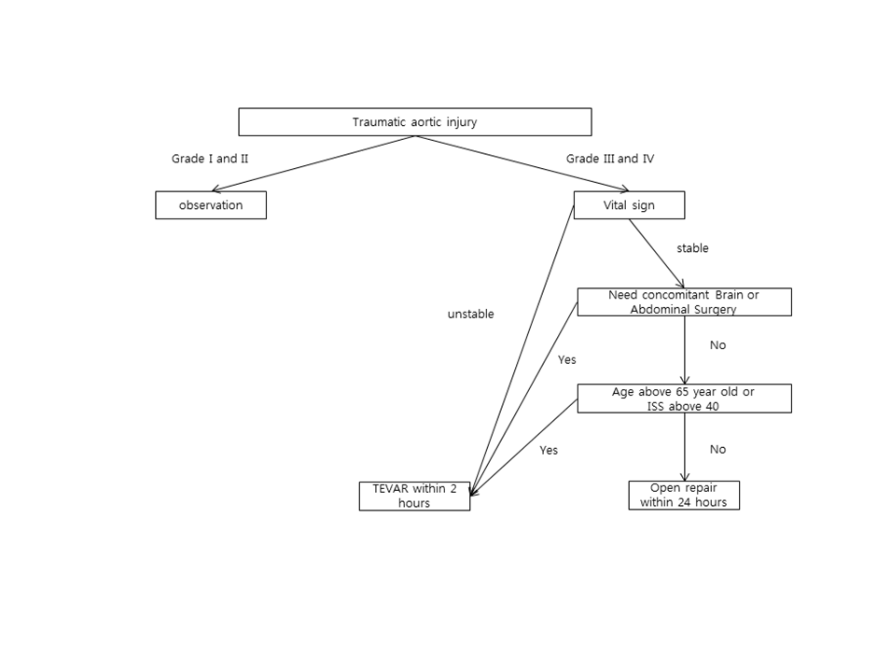

Figure 2. Case of open aortic repair: M/53, incar TA, ISS 29
- The initial computed tomography (CT) scan showing the aortic dissection at the level of isthmus.
- A 3-dimensional reconstruction showing a aortic pseudoaneurysm formed at isthmus.
- Open aortic repair performed using a 22 mm artificial vascular graft(arrow).
- Follow-up CT at 1 year after surgery reveals no abnormality.

Figure 3. case of thoracic endovascular aortic repair with debranching procedure: 48/M incar TA, ISS 50
- Thoracic aortography shows contour deformity due to dissection in aortic isthmus(traumatic aortic injury grade III, arrow)
- In order to secure the proximal landing zone, zone 2 TEVAR covering the left subclavian artery was performed using a stent-graft. The base of the left subclavian artery was embolized(arrow).
- The left carotid-subclavian bypass surgery was performed before TEVAR(arrow). The final thoracic aortography reveals no endoleak, good blood flow through the bypass graft.
- Follow-up CT at 1 year after surgery shows no abnormal changes.

