TABLES
(Table 1) Patient characteristics
Patient characteristics | Sternotomy  (n=158) | VATS  (n=33) | Thoracotomy  (n=10) |  | p value
Sex, male (n, %) | 109 (69) | 19 (57.6) |  | 7 (70) | 0.433
Age, mean ± SD (years) | 57.7±10.6 | 60±11.7 |  | 59.2±8.1 | 0.497
Smoking history  none  ex-smoker  current smoker | 73 (46.2)  48 (30.4)  37 (23.4) | 20 (60.6)  8 (24.2)  5 (15.2) |  | 5 (50)  4 (40)  1 (10) | 0.551
Symptom  none  chest pain  cough  face/arm swelling  dyspnea | 89 (56.3)  43 (27.2)  13 (8.2)  3 (1.9)  9 (5.7) | 25 (75.8)  3 (9.1)  2 (6.1)  0  2 (6.1) |  | 5 (50)  2 (20)  1 (10)  0  2 (20) | 0.188
ECOG  0  1  2  3 or 4 | 127 (80.9)  29 (18.5)  1 (0.6)  0 | 28 (84.8)  4 (12.1)  0  1 (3) |  | 7 (70)  3 (30)  0  0 | 0.283
FEV1 (% predicted)  ≥ 80  < 80 | 110 (81.5)  25 (18.5) | 21 (91.3)  2 (8.7) |  | 7 (77.8)  2 (22.2) | 0.557
DLCO (% predicted)  ≥ 80  < 80 | 62 (73.8)  22 (26.2) | 10 (71.4)  4 (28.6) |  | 5 (62.5)  3 (37.5) | 0.847
BMI (kg/m²) | 24±3.1 | 23.8±1.8 |  | 25.2±2.7 | 0.338
Co-morbidity  Diabetes  Hypertension  COPD  Autoimmune disease | 19 (12)  52 (32.9)  6 (3.8)  1 (0.6) | 3 (9.1)  9 (27.3)  1 (3)  1 (3) |  | 1 (10)  5 (5)  0  0 | 0.911  0.407  1.000  0.383
Preoperative biopsy | 66 (41.8) | 5 (15.2) |  | 5 (50) | 0.012
Neoadjuvant treatment  Concurrent CRTx  Chemotherapy  Radiotherapy | 35 (22.2)  5 (3.2)  28 (17.7)  2 (1.3) | 0  0  0  0 |  | 3 (30)  0  3 (30)  0 | 0.008
Response of neoadjuvant treatment  Partial response  Stable disease | 21 (77.8)  6 (3.8) | 0  0 |  | 2 (66.7)  1 (33.3) | 0.031
ECOG, European Cooperative Oncology Group; COPD, Chronic obstructive pulmonary disease
(Table 2) Preoperative radiologic findings

Variables | Sternotomy  (n=158) | VATS  (n=33) | Thoracotomy (n=10) | p value
Tumor location  Median  Right  Left | 36 (23.7)  62 (40.8)  54 (35.5) | 6 (18.8)  14 (43.8)  12 (37.5) | 0  1 (10)  9 (90) | 0.026
Tumor size | 5.8±2 | 3.8±1.1 | 4.9±1.3 | <0.001
Clinical TNM stage  I  II  IIIA  IIIB  IVA  IVB | 76 (49.4)  6 (3.9)  20 (13)  3 (1.9)  17 (11)  32 (20.8) | 30 (90.9)  0  0  1 (3)  0  2 (6.1) | 3 (30)  1 (10)  1 (10)  1 (10)  3 (30)  1 (10) | 0.001
Clinical Masaoka-Koga stage  I  IIa  IIb  III  IVa  IVb | 40 (25.3)  2 (1.3)  18 (11.4)  59 (37.3)  19 (12)  20 (12.7) | 20 (60.6)  1 (3)  5 (15.2)  5 (15.2)  0  2(6.1) | 1 (10)  1 (10)  0  6 (60)  2 (20)  0 | <0.001
Vascular invasion  Superior Vena Cava  Right innominate vein  Left innominate vein  Innominate artery  Main pulmonary artery  Aorta | 24 (13.7)  13 (8.5)  2 (1.3)  5 (3.3)  2 (1.3)  1 (0.7)  1 (0.7) | 1 (3)  0  0  0  1 (3)  0  0 | 1 (10)  0  0  0  0  1 (10)  0 | 0.049
Mediastinal invasion  Pericardium  Chest wall  Phrenic nerve  Others | 18 (18.8)  9 (5.8)  3 (1.9)  3 (1.9)  3 (1.9) | 0  0  0  0  0 | 1 (10)  1 (10)  0  0  0 | 0.086
Lung invasion | 11 (7) | 0 | 2 (20) | 0.066
Pleural effusion  None  Unilateral  Bilateral | 147 (96.1)  5 (3.3)  1 (0.7) | 32 (97)  1 (3)  0 | 8 (80)  2 (20)  0 | 0.172
Mediastinal lymph node enlargement | 20 (13) | 0 | 1 (10) | 0.056
Pleural nodule | 11 (7.1) | 0 | 2 (20) | 0.066
Lung nodule | 28 (18.3) | 2 (6.1) | 1 (10) | 0.190
SUV max | 8±3.2 | 5.7±1.8 | 8.3±4.5 | 0.237
SUV: Standardized Uptake Values

(Table 3) Operative findings & procedures
Variables | Sternotomy  (n=158) | VATS  (n=33) | Thoracotomy (n=10) | p value
Extent  Thymomectomy  Partial thymectomy  Total thymectomy | 17 (10.8)  7 (4.4)  134 (84.8) | 19 (57.6)  7 (21.2)  7 (21.2) | 5 (50)  1 (10)  4 (40) | <0.001
Tumor size | 6.4±2.3 | 4.6±1.8 | 3.9±2 | <0.001
Lymph node dissection | 80 (50.6) | 8 (24.2) | 6 (60) | 0.015
Additional procedure  Lung, wedge resection  Lung, segmentectomy  Lung, lobectomy  Lung, extrapleural pneumonectomy  Diaphragm, resection  Pericardium, resection  Innominate vein, resection  Phrenic nerve, resection | 133 (84.2)  92 (58.2)  2 (1.3)  5 (3.2)  0  2 (1.3)  80 (50.6)  46 (29.1)  45 (28.5) | 9 (27.3)  5 (15.2)  0  1 (3)  0  0  4 (12.1)  0  2 (6.1) | 9 (90)  5 (50)  1 (10)  2 (20)  1 (10)  1 (10)  7 (70)  2 (20)  4 (40) | <0.001  <0.001  0.209  0.079  0.050  0.209  <0.001 <0.001  0.015
Clinical resection status  Complete  Incomplete | 146 (92.2)  12 (7.6) | 32 (97)  1 (3) | 8 (80)  2 (20) | 0.210
Operation time (min) | 235 (115-736) | 147 (99-196) | 356 (305-408) | <0.001
Blood loss | 350 (22-8000) | 135 (50-22) | 825 (450-1200) | <0.001
Transfusion | 39 (24.8) | 0 | 3 (30) | 0.005

(Table 4) Pathologic findings

Variables | Sternotomy  (n=158) | VATS  (n=33) | Thoracotomy (n=10) | p value
Pathologic TNM stage  I  II  IIIA  IIIB  IVA  IVB | 57 (36.1)  10 (6.3)  43 (27.2)  11 (7)  20 (12.7)  17 (10.8) | 27 (81.8)  1 (3)  0  1 (3)  2 (6.1)  2 (6.1) | 2 (20)  1 (10)  2 (20)  0  4 (40)  1 (10) | <0.001
Subtype  Squamous cell carcinoma  Lymphoepithelioma-like  Sarcomatoid  Mucoepidermoid  Adenocarcinoma  Clear cell carcinoma  NOS | 119 (78.3)  6 (3.9)  3 (2)  2 (1.3)  3 (2)  1 (0.7)  11 (7.2) | 29 (87.9)  0  0  0  0  0  4 (12.1) | 9 (90)  0  0  0  0  0  0 | 0.861
Complete resection  R0  R1  R2 | 128 (81)  29 (18.4)  1 (0.6) | 32 (97)  0  1 (3) | 7 (70)  3 (30)  0

(Table 5) Postoperative outcome

Variables | Sternotomy  (n=158) | VATS  (n=33) | Thoracotomy (n=10) | p value
Mortality at 30 days (n, %) | 2 (1.3) | 0 | 0 | 1.000
Chest tube duration (days) | 5 (2-13) | 0 | 1.5 (0-3) | <0.001
Ventilation duration (days) | 0 (0-6) | 0 | 1 (0-2) | <0.001
ICU stay (days) | 2 (0-11) | 0 | 5 (1-9) | <0.001
Hospital stay (days) | 10 (3-44) | 7 (4-10) | 12.5 (7-18) | <0.001
Adjuvant therapy (%)  None  Chemotherapy  Radiotherapy  Concurrent chemoradiotherapy | 30 (19)  35 (22.2)  73 (46.2)  20 (12.7) | 10 (30.3)  4 (12.1)  15 (45.5)  4 (12.1) | 3 (30)  4 (40)  3 (30)  0 | 0.350
Complications (n, %)  Prolonged air leak (n, %)ª  Atelectasis  Pneumonia (n, %)  ALI/ARDS (n, %)^{b}  PTE (n, %)  Re-intubation  Chylothorax (n, %)  Arrhythmia (n, %)  Wound infection (n, %)  Bleeding  Grade  I  II  III  IV | 44 (27.8)  1 (0.6)  2 (1.3)  0  1 (0.6)  1 (0.6)  1 (0.6)  2 (1.3)  8 (5.1)  1 (0.6)  2 (1.3)  11 (7)  21 (13.3)  10 (6.3)  2 (1.3) | 3 (9.1)  0  0  0  0  0  0  1 (3)  0  0  0  2 (6.1)  0  0  1 (3) | 0  0  0  0  0  0  0  0  0  0  0  0  0  0  0 | 0.014  0.134
- air leak lasting more than 5 days, b. ALI/ARDS: acute lung injury/acute respiratory distress syndrome
(Table 6) Postoperative outcome of patients with tumor less than 5cm and TNM stage I

Variables | Sternotomy  (n=28) | VATS  (n=27) | p value
Extent  Thymomectomy  Partial thymectomy  Total thymectomy | 2 (7.1)  0  26 (92.9) | 16 (59.3)  5 (18.5)  6 (22.2) | <0.001
Pathologic tumor size (cm) | 4.7±1.7 | 4.2±1.6 | 0.182
Pathologic TNM stage  I  II  IIIA  IIIB  IVA  IVB | 17 (60.7)  2 (7.1)  6 (21.4)  0  3 (10.7)  0 | 22 (81.5)  0  0  1 (3.7)  2 (7.4)  2 (7.4) | 0.013
Concomitant procedure  Lung, wedge resection  Lung, lobectomy  Pericardium, resection  Innominate vein, resection  Phrenic nerve, resection | 21 (75)  14 (50)  0  12 (42.9)  8 (28.6)  3 (10.7) | 7 (25.9)  4 (14.8)  1 (3.7)  3 (11.1)  0  2 (7.4) | <0.001  0.005  1.000  0.008  0.004  1.000
Operation time (min) | 175 (115-535) | 102 (13-215) | <0.001
Blood loss (mL) | 375 (0-2000) | 5 (0-400) | <0.001
Transfusion | 3 (10.7) | 0 | 0.236
Complete resection  R0  R1  R2 | 28 (100)  0  0 | 26 (96.3)  0  1 (3.7) | 0.491
Mortality at 30 days (n, %) | 0 | 0 | 1.000
Chest tube duration | 4 (2-13) | 2 (1-7) | <0.001
Ventilation duration | 0 (0-2) | 0 | 0.051
ICU stay (days) | 1 (0-5) | 0 (0-1) | <0.001
Hospital stay (days) | 8 (3-20) | 4 (2-13) | <0.001
Adjuvant therapy (%)  None  Chemotherapy  Radiotherapy  Concurrent chemoradiotherapy | 7 (25)  4 (14.3)  14 (50)  3 (10.7) | 10 (37)  3 (11.1)  10 (37)  4 (14.8) | 0.755
Complications (n, %)  Prolonged air leak (n, %)ª  Atelectasis  Pneumonia (n, %)  ALI/ARDS (n, %)^{b}  PTE (n, %)  Re-intubation  Chylothorax (n, %)  Arrhythmia (n, %)  Wound infection (n, %)  Bleeding (n, %)  Others (n, %)  Grade  I  II  III  IV | 6 (21.4)  0  0  0  0  0  1  2  2  0  0  1  2  3  1  0 | 2 (7.4)  0  0  0  0  0  1  0  0  0  0  1  2  0  0  0 | 0.252  0.296
Recurrence  Local  Regional  Distant | 8 (28.6)  3  3  2 | 5 (18.5)  3  1  1 | 0.380  0.790
ICU: Intensive care unit

(Figure 1) Overall survival (A) and Recurrence-free survival (B) of 201 patients

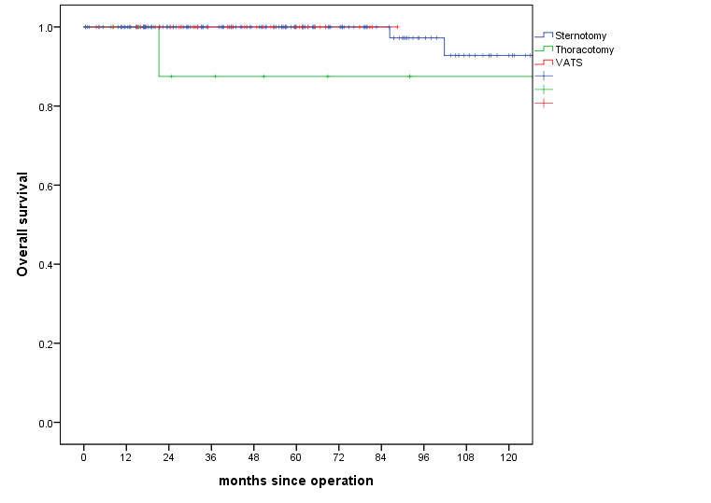
(A)

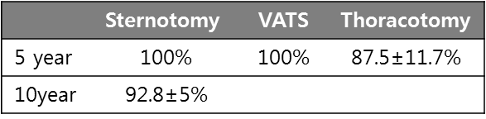
Log-rank
p=0.107

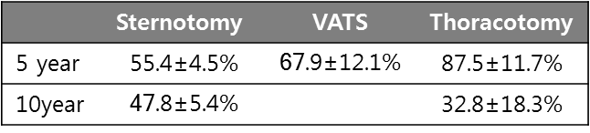
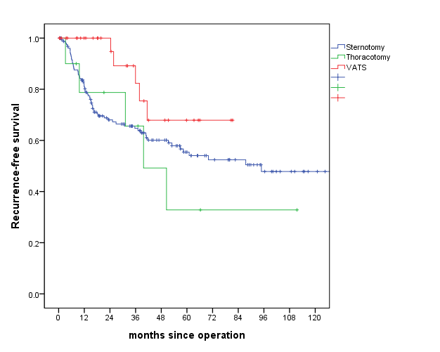
(B)
Log-rank
p=0.131
(Figure 2) Overall survival (A) and Recurrence-free survival (B) of patients with tumor less than 5cm and TNM stage I
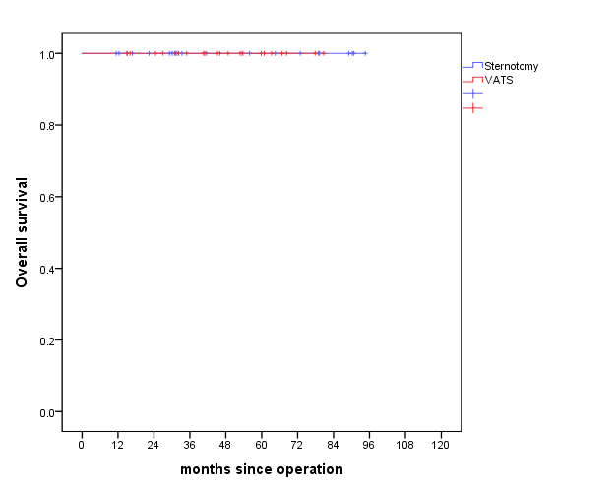
(A)

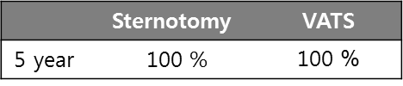

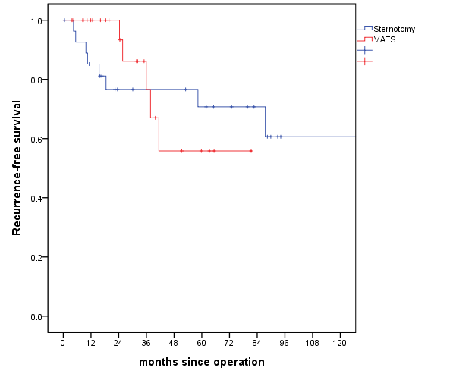
(B)

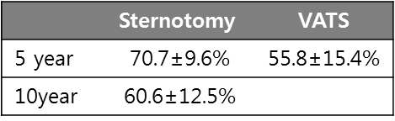
Log-rank
p=0.960

